Drools Expert-Level Guide (Enhanced Edition)
From Rule Author to Decision Platform Architect

1. Mental Model Upgrade: How Experts Think About Drools

Beginner Thinking
“Rules are if–then logic executed by an engine.”

Expert Thinking
“Rules are versioned, composable decision assets executed by a policy-aware inference engine that must be auditable, explainable, and region-configurable.”
Key mindset shifts:
From | To
Rule files | Rule products
DRL logic | Decision intent
Stateless execution | Context-aware decisioning
Single ruleset | Layered rule groups
Local dev | Globally deployed decision services

2. Advanced Rule Organization: Rulesets, Rule Groups, and Decision Layers

2.1 Ruleset ≠ Rule File
Ruleset (Expert Definition):
A versioned, deployable collection of rules that fulfills one business decision responsibility.
Examples:
- TravelDelayEligibilityRuleset
- AutoBISettlementRuleset
- FraudPreScreenRuleset
Each ruleset should:
- Have a clear decision contract
- Be independently versioned
- Produce a decision outcome, not just side effects

2.2 Rule Groups (Salience-Free Design)
Avoid heavy reliance on salience. Instead, structure explicit execution stages.

Recommended Rule Group Taxonomy
rules/
├── 01_validation/
├── 02_normalization/
├── 03_eligibility/
├── 04_calculation/
├── 05_exceptions/
├── 06_enrichment/
└── 07_final_decision/
Each folder:
- Maps to a decision phase
- Has clear entry/exit assumptions
- Is testable in isolation
💡 Rule groups are architectural boundaries, not just folders.

2.3 Agenda Groups vs Ruleflow Groups
Feature | Use Case
agenda-group | Simple sequencing
ruleflow-group | BPMN / orchestration
Stateless sessions | High-volume STP
Stateful sessions | Investigations / long-lived cases
Expert Rule:
👉 Prefer ruleflow-group when rules map to business process stages.

3. Rule Templates: The Key to Global Reusability

3.1 Why Templates Matter at Scale
Without templates:
- Rules explode by region
- Logic gets duplicated
- Changes become ungovernable
With templates:
- Logic = stable
- Data = configurable
- Regions = data-driven

3.2 Template Design Principles
Bad Template
Rule = Logic + Constants
Good Template
Rule = Logic + Parameters + Metadata

3.3 Canonical Template Example (Insurance-Grade)
rule "Eligibility - @{coverageCode} - @{region}"
agenda-group "eligibility"
when
Claim(
coverageCode == "@{coverageCode}",
lossRegion == "@{region}",
lossAmount >= @{minAmount},
lossAmount <= @{maxAmount}
)
then
decision.markEligible(
"@{decisionCode}",
"@{reasonCode}"
);
end
CSV Example
coverageCode,region,minAmount,maxAmount,decisionCode,reasonCode
TRAVEL_DELAY,EMEA,300,5000,ELIGIBLE,TD_EMEA_STD
TRAVEL_DELAY,APAC,200,3000,ELIGIBLE,TD_APAC_STD

3.4 Template Governance Strategy
Layer | Ownership
Template logic | Platform / Architecture
Parameter values | Business / Product
CSV storage | Config repo or DB
Approval | Decision governance workflow

4. Global Deployment Best Practices (Critical)

4.1 Region-Aware Rule Design
Never hardcode geography.
Use:
- regionCode
- jurisdiction
- regulatoryContext
when
Claim(region == Region.EMEA)
Instead of:
when
Claim(country == "Germany")

4.2 Rule Inheritance via Composition (Not Copy-Paste)
Base Ruleset
- Global defaults
Overlay Ruleset
- Region-specific deltas
Execution model:
Global → Regional → Product → Exception

4.3 Versioning Strategy (Non-Negotiable)
Asset | Versioned?
DRL | ✅
Templates | ✅
CSVs | ✅
Decision outcome | ✅
Semantic versioning recommended
TravelDelayEligibilityRuleset
├── 1.3.0 (logic change)
├── 1.3.1 (threshold update)

5. Reusability Patterns (Expert-Level)

5.1 Rule as Capability, Not as Flow
Bad:
“This rule only works in FNOL”
Good:
“This rule evaluates eligibility regardless of entry point”
Rules should be:
- Channel-agnostic
- System-agnostic
- Reusable by FNOL, Adjuster UI, Simulation, AI agents

5.2 Decision Object Pattern
Avoid mutating the Claim directly.
Decision decision = new Decision();
Rules write to Decision, not to domain objects.
Benefits:
- Explainability
- Replayability
- Simulation support

6. Explainability & Audit (Enterprise-Critical)

6.1 Structured Decision Output
Each rule must emit:
- Rule ID
- Rule version
- Reason code
- Confidence / severity (optional)
decision.addEvidence(
"ELIGIBILITY_RULE_102",
"TD_AMOUNT_THRESHOLD_MET",
Severity.HIGH
);

6.2 Traceability for Regulators
Store:
- Input snapshot
- Fired rules
- Output decision
- Rule version hash
This enables:
- Regulatory audits
- Claim disputes
- Model drift analysis

7. Performance & Scaling

7.1 Stateless Session Best Practices
- One request → one session
- No globals with mutable state
- No static caches inside rules

7.2 Fact Design for Performance
Bad | Good
Large domain objects | Lean projection facts
Nested conditions | Precomputed flags
String comparisons | Enums / ints

8. Testing Strategy (Beyond Unit Tests)

8.1 Rule Unit Tests
- One rule
- One scenario
- One expected outcome

8.2 Ruleset Scenario Tests
- End-to-end decision
- Golden datasets

8.3 Regression Packs
- Historical claims replayed
- Required for every deployment

9. CI/CD & Promotion (Enterprise-Grade)

9.1 Pipeline Stages
Validate DRL
→ Compile Rules
→ Run Scenario Tests
→ Package KJAR
→ Deploy to Artifact Repo
→ Promote to Env

9.2 Environment Strategy
Env | Purpose
DEV | Rule authoring
SIT | Integration
UAT | Business validation
PROD | Locked logic

10. Anti-Patterns (What Experts Avoid)
❌ Hardcoded values
❌ Copy-pasted rules
❌ Salience wars
❌ Rule logic tied to UI
❌ No versioning
❌ No explainability

11. Final Expert Checklist
Before calling yourself Drools Expert, you should be able to:
- Design reusable rule templates
- Support multi-region deployments
- Explain every decision to an auditor
- Version and promote rules safely
- Simulate decisions at scale
- Integrate rules with AI-generated inputs
- Treat rules as products, not scripts

Part 2

Drools for Insurance STP
An Expert-Level Guide to Decision Automation at Enterprise Scale

1. Purpose of This Document
This document defines how Drools should be designed, structured, governed, tested, deployed, and operated as the core deterministic decision engine in an insurance Straight-Through Processing (STP) platform.
It is intended for:
- Platform architects
- Senior engineers
- Rules engineers
- Claims and underwriting decision designers
- AI / decision automation teams
The focus is not just “how to write rules”, but how to build a sustainable, global decision platform using Drools.

2. Role of Drools in Insurance STP

2.1 Why Drools Exists in STP
In insurance STP, Drools is used to:
- Make deterministic, explainable decisions
- Enforce regulatory and contractual rules
- Enable consistent outcomes across channels
- Support high-volume, low-latency automation
Drools is not:
- A workflow engine
- A UI rules engine
- A replacement for AI/ML
- A data store
Drools is:
A deterministic decision engine that transforms facts → decisions in a way that is auditable, repeatable, and legally defensible.

2.2 Typical STP Decisions Implemented in Drools
Category | Examples
Eligibility | Is this claim eligible for coverage?
Thresholds | Is loss amount within auto-settlement limits?
Routing | Can this be STP or must it go to an adjuster?
Compliance | Does jurisdiction require manual review?
Exception handling | Does any exclusion apply?
Calculations | Payout caps, deductibles, waiting periods
Pre-fraud screening | Deterministic fraud indicators

3. Core Design Principles (Non-Negotiable)

3.1 Determinism Over Intelligence
Drools decisions must always:
- Produce the same output for the same input
- Be explainable without probabilistic reasoning
- Be replayable months or years later
AI may assist Drools (e.g., classification, extraction), but Drools owns the final deterministic decision.

3.2 Rules Are Products, Not Scripts
Every ruleset should be treated as:
- A versioned product
- With a defined contract
- With owners
- With a lifecycle
If you cannot answer:
- What decision does this ruleset own?
- Who owns it?
- How is it tested?
- How is it deployed?
Then the ruleset is not production-ready.

4. STP Decision Architecture with Drools

4.1 Position in the STP Flow
Typical STP flow:
FNOL Intake
↓
Normalization & Enrichment
↓
AI / NLP / Extraction (optional)
↓
Drools Decision Engine
↓
Outcome Routing
↓
Settlement / Manual Review
Drools must not:
- Call external systems
- Depend on runtime IO
- Perform orchestration
Drools only evaluates facts already provided.

5. Ruleset Architecture

5.1 What Is a Ruleset?
A ruleset is a cohesive collection of rules that:
- Owns a single business decision
- Produces a clear outcome
- Can be versioned independently
Examples:
- TravelDelayEligibilityRuleset
- AutoGlassSTPDecisionRuleset
- HealthClaimPreAuthRuleset

5.2 Ruleset Boundaries
A ruleset:
- Must not span multiple unrelated decisions
- Must not depend on execution order of other rulesets
- Must be callable as a pure function
Decision = evaluate(Facts)

6. Rule Grouping and Execution Phases

6.1 Execution Phases (Recommended)
Rules should be grouped by decision phase, not by feature.
rules/
├── 01_validation/
├── 02_normalization/
├── 03_eligibility/
├── 04_calculation/
├── 05_exclusions/
├── 06_routing/
└── 07_final_decision/
Each phase:
- Has a single responsibility
- Can be tested independently
- Can be reasoned about by business users

6.2 Agenda Groups vs Ruleflow Groups
Feature | Usage
agenda-group | Simple sequencing
ruleflow-group | BPMN / orchestration
Stateless session | High-volume STP
Stateful session | Long-running investigations
Best Practice
- Use agenda-group for most STP
- Introduce ruleflow-group only when mapping directly to business workflows

7. Global Deployment Strategy

7.1 Region-Aware Design
Never hardcode:
- Country names
- Jurisdiction logic
- Regulatory rules
Always externalize:
- Region
- Jurisdiction
- Regulatory context
when
Claim(regulatoryContext == RegulatoryContext.EMEA)

7.2 Layered Rule Composition
Use overlay patterns, not duplication:
Global Rules
↓
Regional Rules
↓
Product Rules
↓
Exception Rules
This enables:
- Global consistency
- Local flexibility
- Controlled variance

8. Rule Templates (Critical for STP Scale)

8.1 Why Templates Are Mandatory
Without templates:
- Rules explode combinatorially
- Maintenance becomes impossible
- Regional rollout slows dramatically
Templates allow:
- One logic definition
- Thousands of parameterized rules

8.2 Template Design Principles
A template should:
- Contain only logic
- Accept all variability as parameters
- Be owned by the platform team
Bad:
Logic + values in DRL
Good:
Logic in DRL template, values in CSV / config

8.3 Insurance-Grade Template Example
rule "Eligibility - @{coverageCode} - @{region}"
agenda-group "eligibility"
when
Claim(
coverageCode == "@{coverageCode}",
lossRegion == "@{region}",
lossAmount >= @{minAmount},
lossAmount <= @{maxAmount}
)
then
decision.markEligible(
"@{decisionCode}",
"@{reasonCode}"
);
end

9. Decision Output Model (Mandatory)

9.1 Never Mutate Domain Objects
Rules must not directly change Claim, Policy, or Coverage.
Instead, write to a Decision object.
Decision decision = new Decision();
Benefits:
- Explainability
- Replayability
- Auditability
- Simulation support

9.2 Decision Evidence
Each rule should emit structured evidence:
decision.addEvidence(
ruleId,
ruleVersion,
reasonCode,
Severity.HIGH
);
This enables:
- Claim dispute resolution
- Regulatory audits
- AI explainability overlays

10. Explainability & Auditability

10.1 Required Audit Artifacts
For every STP decision, persist:
- Input fact snapshot
- Fired rules
- Rule versions
- Decision output
- Timestamp and environment
This is non-optional in regulated insurance environments.

11. Performance & Scale

11.1 Stateless Session Best Practices
- One request → one session
- No mutable globals
- No static caches
- No external calls

11.2 Fact Optimization
Avoid | Prefer
Large domain graphs | Lean projection facts
Strings | Enums
Deep nesting | Precomputed flags

12. Testing Strategy

12.1 Rule Unit Tests
- One rule
- One scenario
- One expected outcome

12.2 Ruleset Scenario Tests
- End-to-end decision
- Golden datasets

12.3 Regression Packs
- Replay historical claims
- Mandatory for every release

13. CI/CD & Promotion Model

13.1 Pipeline Stages
DRL Validation
→ Compilation
→ Scenario Tests
→ Package (KJAR)
→ Artifact Repo
→ Promote by Environment

13.2 Environment Strategy
Environment | Purpose
DEV | Rule authoring
SIT | Integration
UAT | Business sign-off
PROD | Locked, audited

14. Governance Model

14.1 Ownership
Asset | Owner
Templates | Platform
Rulesets | Product / Business
CSV Parameters | Business
Promotion | Architecture / Ops

14.2 Approval Flow
- Rule authored
- Scenario tests pass
- Business approves
- Architecture signs off
- Promote

15. Anti-Patterns (What Breaks STP)
❌ Hardcoded thresholds
❌ Copy-paste rules
❌ Salience wars
❌ Channel-specific rules
❌ No versioning
❌ No audit trail

16. Final Expert Checklist
You are using Drools correctly for STP if:
- Every decision is explainable
- Rules are region-agnostic
- Templates drive scale
- Rulesets are versioned products
- Decisions can be replayed years later
- AI augments but never replaces determinism

17. How This Fits with AI & Future Platforms
Drools:
- Enforces deterministic truth
- Provides explainable decisions
- Acts as the last line of defense
AI:
- Extracts data
- Classifies intent
- Suggests parameters
- Assists rule authoring
Drools remains the legal decision authority.

18. End-to-End Drools STP Architecture Diagrams

18.1 High-Level Insurance STP Decision Architecture
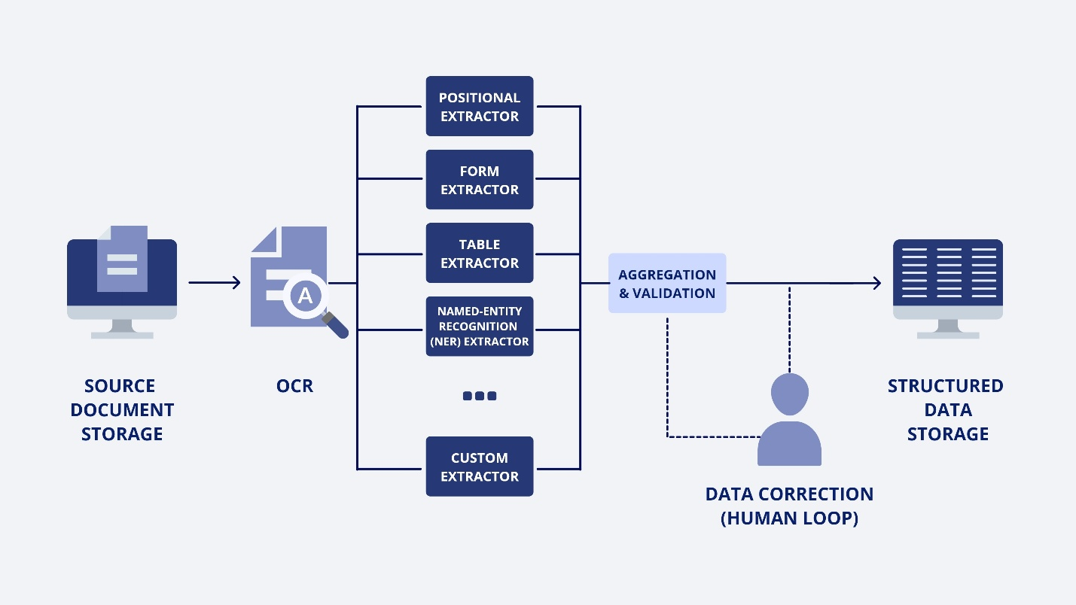

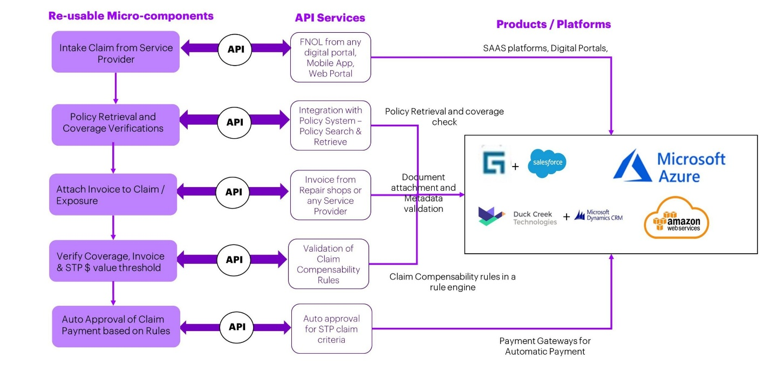

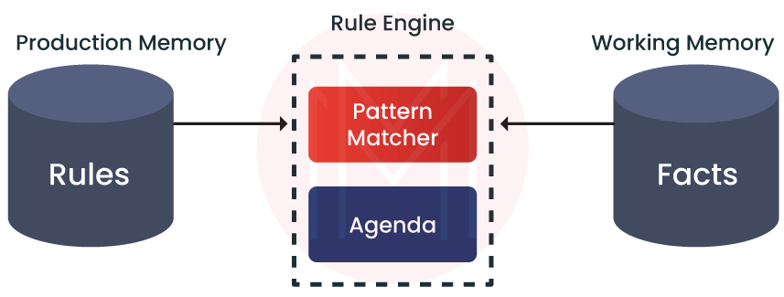

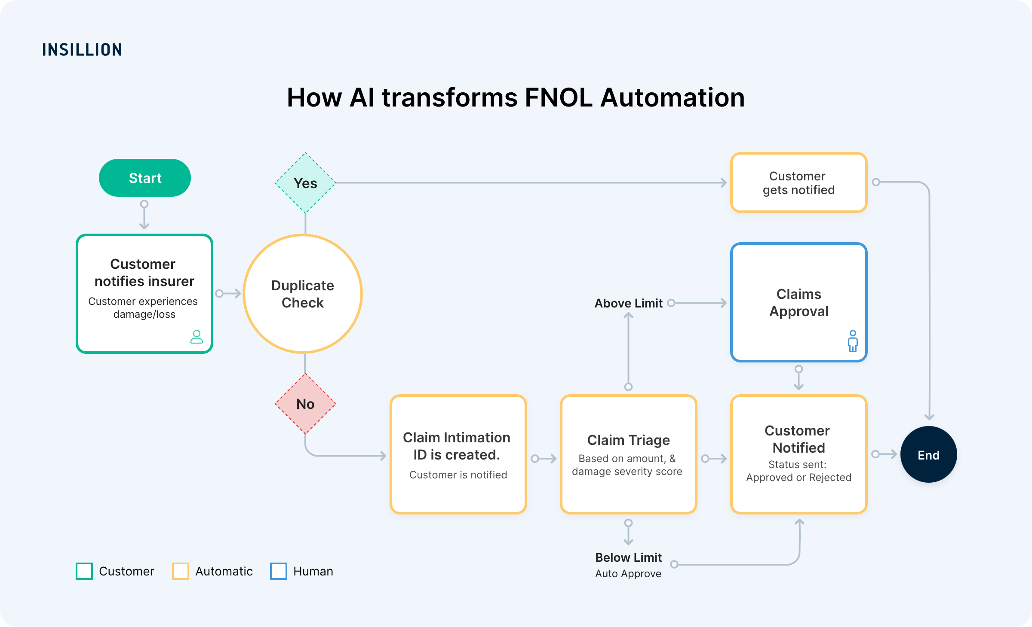

Narrative Walkthrough
Channel (UI / API / Voice / Partner)
↓
FNOL Intake API
↓
Normalization & Canonical Mapping
↓
AI / NLP / Extraction (optional, non-deterministic)
↓
Drools Decision Engine (deterministic)
↓
Decision Outcome
↓
Settlement | Routing | Manual Review
Key architectural rules:
- Drools never depends on channels
- Drools never calls external services
- Drools consumes facts, not raw payloads
- AI enriches facts but never decides

18.2 Detailed Decision Flow with Drools Rule Groups
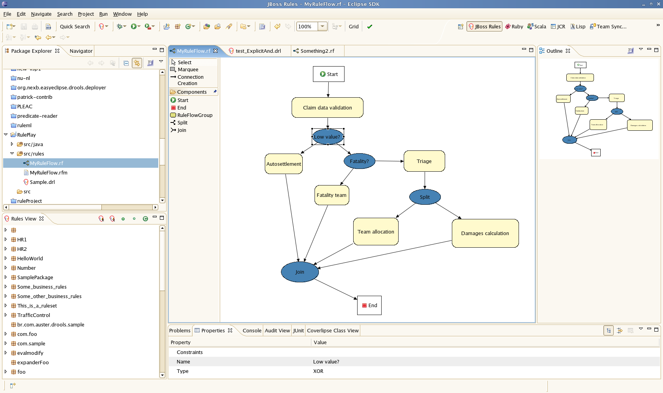

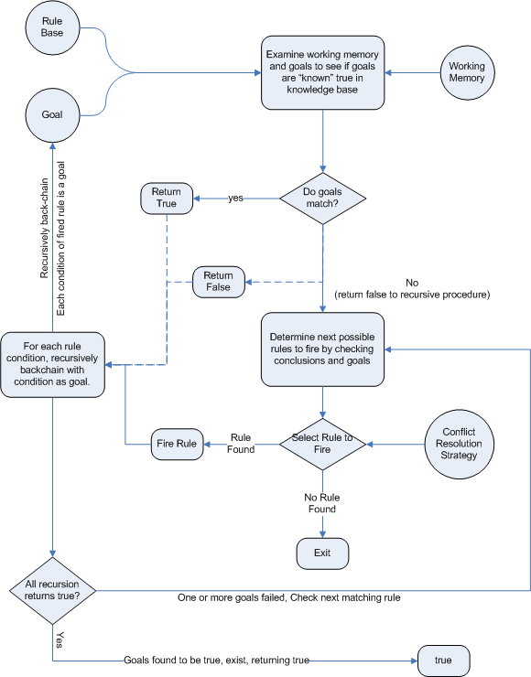
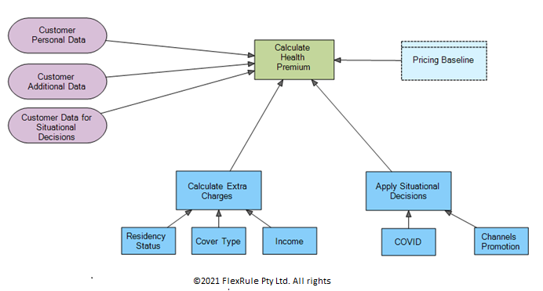

Execution Stages (Rule Groups)
[01 Validation]
↓
[02 Normalization]
↓
[03 Eligibility]
↓
[04 Calculation]
↓
[05 Exclusions]
↓
[06 Routing]
↓
[07 Final Decision]
Each stage:
- Has a single responsibility
- Produces structured decision evidence
- Can short-circuit the flow if required

18.3 Global Deployment & Overlay Model
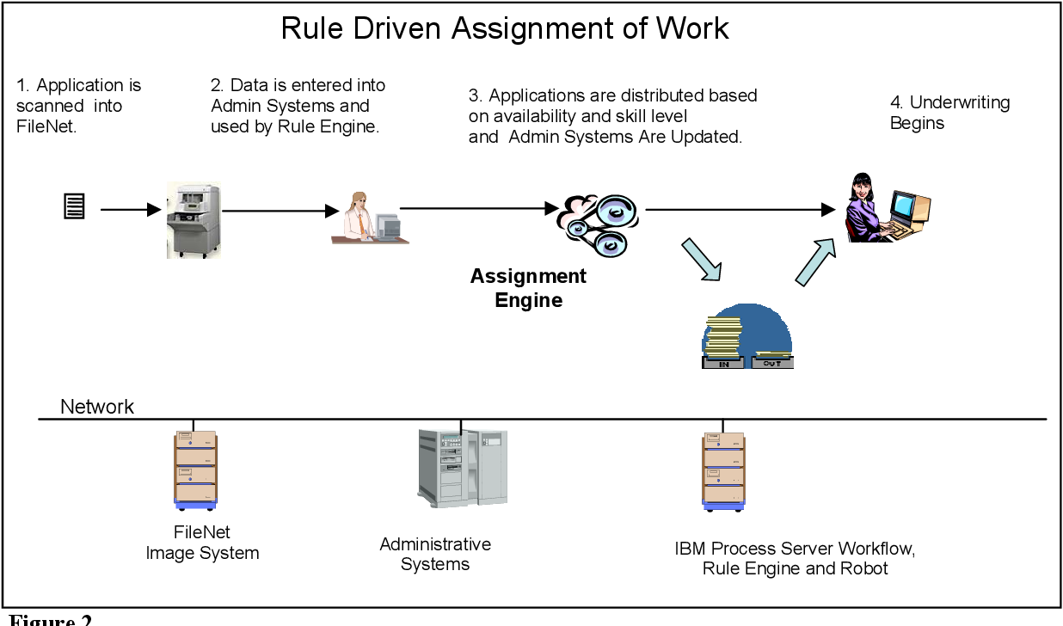

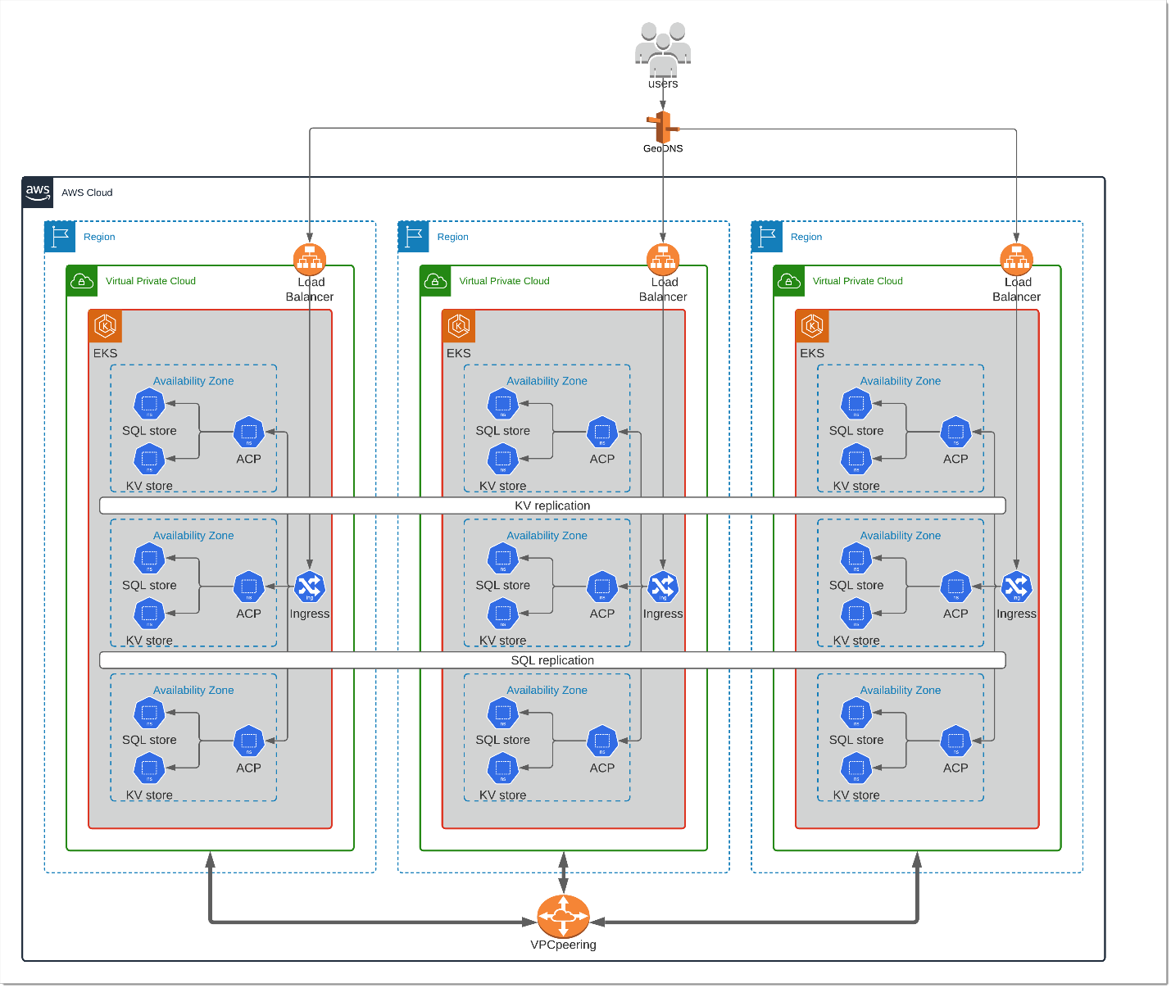


Overlay Strategy (Critical for Global STP)
Global Rules (Base)
↓
Regional Rules (EMEA / APAC / LATAM)
↓
Product Rules (Travel / Auto / Health)
↓
Exception Rules (Regulatory / Carrier-specific)
Why this matters
- Global consistency
- Regional compliance
- Minimal duplication
- Safe evolution

18.4 Decision Evidence & Audit Trail Flow
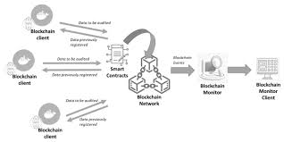
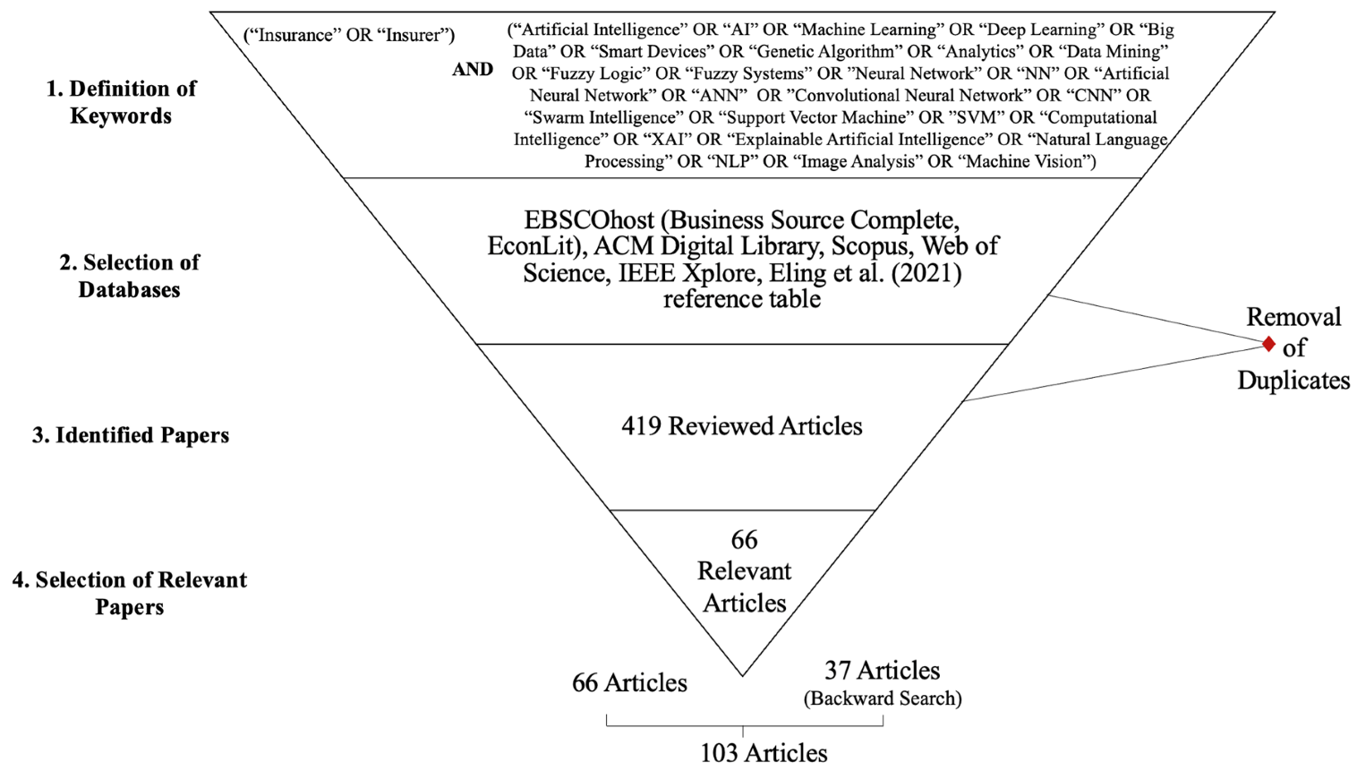
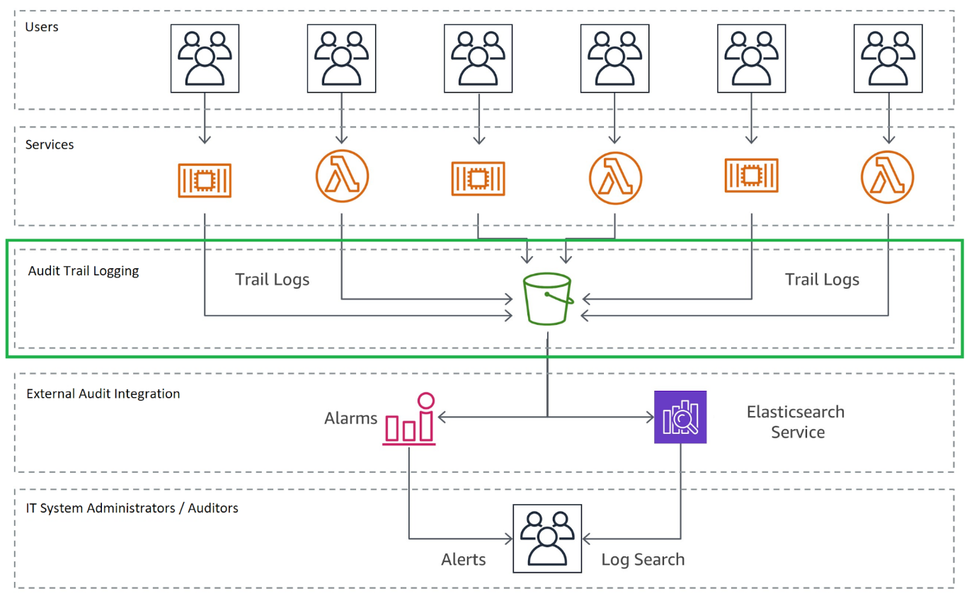

Audit Artifacts Persisted Per Decision
- Input fact snapshot
- Fired rule IDs
- Rule versions
- Decision outcomes
- Reason codes
- Environment & timestamp
This supports:
- Regulatory audits
- Claim disputes
- Model governance
- AI explainability overlays

19. Drools for Insurance STP – Certification Path
This is designed as an internal enterprise certification, not a vendor cert.
Think: “Drools Black Belt for Insurance Decisioning.”

Level 1 – Drools Foundations (Engineer)

Audience
- Software engineers
- Claims / underwriting technologists
- New rules authors

Competencies
- Drools fundamentals
- DRL syntax
- Facts and rules
- Stateless vs stateful sessions

Required Skills
- Write basic rules
- Use agenda groups
- Understand rule execution lifecycle

Assessment
- 10–15 rule exercises
- Simple eligibility ruleset
- Unit tests for rules
✅ Certification Outcome
Certified Drools Rule Author

Level 2 – Insurance Decision Engineer (Senior)

Audience
- Senior engineers
- Claims automation engineers
- STP contributors

Competencies
- Insurance domain modeling
- Rule grouping & phasing
- Decision object patterns
- Explainability

Required Skills
- Build eligibility + routing rules
- Emit structured decision evidence
- Avoid anti-patterns (salience wars, mutation)

Assessment
- Build a Travel Delay STP ruleset
- Explain every fired rule
- Scenario-based testing
✅ Certification Outcome
Certified Insurance Decision Engineer

Level 3 – Ruleset Architect (Staff / Principal)

Audience
- Staff engineers
- Platform architects
- Decision platform owners

Competencies
- Ruleset design
- Template-driven scaling
- Global overlay strategies
- Performance tuning

Required Skills
- Design reusable rule templates
- Support multi-region deployment
- Implement versioning strategy
- Optimize fact models

Assessment
- Design a global ruleset with regional overlays
- Implement templates + CSVs
- CI/CD promotion plan
✅ Certification Outcome
Certified Drools Ruleset Architect

Level 4 – STP Decision Platform Architect (Expert)

Audience
- Principal engineers
- Enterprise architects
- AI + Decision leads

Competencies
- End-to-end STP architecture
- Governance & compliance
- AI + Drools coexistence
- Regulatory explainability

Required Skills
- Position Drools within FNOL → Settlement
- Design audit and replay mechanisms
- Define ownership and approval models
- Integrate AI outputs safely

Assessment
- Whiteboard full STP architecture
- Design decision governance model
- Defend design to legal/compliance
✅ Certification Outcome
Certified STP Decision Platform Architect

Level 5 – Global Decision Authority (Distinguished)

Audience
- Global platform owners
- Architecture council members
- Decision governance leads

Competencies
- Enterprise-scale decisioning
- Regulatory strategy
- Cross-LOB reuse
- Organizational enablement

Required Skills
- Define decision standards
- Govern global rollouts
- Align AI, rules, and humans
- Mentor rule architects

Assessment
- Define enterprise decision standards
- Create certification curriculum
- Review and approve rulesets globally
🏆 Certification Outcome
Global Decision Authority – Insurance STP

Final Thought
If engineers only know DRL syntax, they are rule coders.
If they understand:
- decision boundaries
- templates
- explainability
- governance
- global deployment
They become decision engineers.
And at scale, decision engineering is the real competitive advantage in insurance STP.

Part 3

The Decision Engineering Hierarchy (Expert Model)
Think of Drools as a runtime execution engine inside a broader Decision Platform. So the hierarchy has two layers:
- Business / Platform layer (what you govern, version, and promote)
- Drools / KIE layer (what actually compiles and runs)

Layer 1: Decision Platform (Business Assets)
Decision (Capability) → Ruleset → Ruleset Version → Content Sources (Rules / Templates / Decision Tables / Params)

Layer 2: KIE Runtime (Execution Assets)
KJAR → KIE Module → KIE Base → KIE Session → Working Memory (Facts) → Agenda → Fired Rules

1) Decision (Capability) — The Missing Top Node

What it is
A Decision is the business capability you’re automating, e.g.:
- “Travel Delay Adjudication”
- “Auto STP Routing”
- “Coverage Eligibility”
- “Payment Approval”

Why it matters
This is the unit stakeholders and auditors understand.

Relationship
A Decision is implemented by one or more Rulesets (common in large programs):
- one ruleset for eligibility
- one for payout calculation
- one for routing / exceptions

2) Ruleset (Rule Product) — The Deployable Decision Unit

What it is
A Ruleset is a decision product: a cohesive package of rules logic that answers one business question.
Example:
- TravelDelayAdjudicationRuleset

What it contains (conceptually)
- many rules
- grouped into phases (rule groups)
- possibly generated from templates or decision tables
- associated parameters (thresholds per region/product)
- metadata: owner, region scope, effective dates, approval state

Versioning
Rulesets MUST be versioned because they represent immutable decision logic used for audit/replay:
- TravelDelayAdjudicationRuleset v2.1.0

Relationship
- Decision → Ruleset: 1-to-many (sometimes 1-to-1)
- Ruleset → Ruleset Version: 1-to-many
- Ruleset Version → Executable Artifact (KJAR): 1-to-1 (recommended)
Key principle: rules are reusable at design time, but each ruleset version freezes a snapshot for runtime.

3) Ruleset Version — The Frozen Snapshot (Audit Anchor)

What it is
A specific immutable snapshot of a ruleset:
- exact DRL content
- exact templates/decision tables resolved
- exact parameter versions (if externalized)
- exact dependencies

Why it matters
When someone asks “which logic was used?” the answer is:
- ruleset name + version (+ artifact hash)

Relationship
At runtime you log:
- rulesetVersion
- which rule IDs fired
- optionally the rule content hash(es)
This is your audit + replay foundation.

4) Rule — The Reusable Unit of Logic (But Not a Deployable Unit)

What it is
A Rule is an atomic piece of logic:
- IF conditions match facts
- THEN produce decision evidence / actions

Identity vs Version
Rule ID should be stable across edits if the business intent is the same:
- POLICY_ACTIVE_ON_LOSS_DATE
Do not treat rule versioning as a deployment mechanism.
Instead:
- rule revision can exist as metadata (commit hash / revision stamp)
- but ruleset version is the governance version

Reuse across rulesets
This is the point you raised (correctly):
- A rule like “Policy must be active on date of loss” is used in many decisions.
- Therefore: Rule has no intrinsic rulesetId.
- Association is many-to-many via a composition record:
RulesetComposition (join)
- rulesetId
- ruleId
- ruleGroup / phase
- enabled flag
- optional overrides

Relationship
- Rule Library → many Rulesets
- Ruleset Version → contains a compiled snapshot of rules

5) Rule Group — The Execution Phase (Order + Structure)

What it is
A Rule Group is not a “business asset”—it’s an execution structuring mechanism.
Its purpose:
- make rules maintainable
- prevent salience wars
- enforce phased evaluation (validation → eligibility → calc → routing)

In Drools terms
Rule groups typically map to:
- agenda-group (most common)
- ruleflow-group (if orchestrated via BPMN / process)

Relationship
- Ruleset contains multiple Rule Groups
- Rule belongs to exactly one group within a ruleset (best practice)
- Same rule reused in another ruleset can be placed into a different group (often still “validation”)
Rule groups define “how to evaluate” inside a ruleset.
They do not define “what decision” (that’s ruleset).

6) Rule Template — Logic Pattern with Parameters (Scaling Mechanism)

What it is
A template is a rule generator pattern:
- stable DRL structure
- placeholders for variable content
- driven by parameter rows (CSV/DB)
Used when:
- the logic is consistent
- thresholds vary by region, product, partner, coverage, etc.

Relationship
Templates generate many rules that end up inside a ruleset version.
So:
- Template (pattern) → produces Rules (instances)
- Rules → organized into Rule Groups
- Ruleset Version → freezes generated rules

Why templates matter for global STP
They enable:
- EMEA/APAC/LATAM differences as parameters, not copy-pasted rules
- faster rollout
- consistent governance

7) Decision Table — Business-Friendly Bulk Rule Authoring

What it is
A Decision Table is a structured tabular way to define many rules.
Drools supports decision tables (often XLS/CSV) that compile to rules.
Use when:
- business wants to manage thresholds/conditions in a tabular form
- rule logic fits a “row = rule” mental model
Avoid when:
- logic requires complex joins, temporal constraints, or deep object graph reasoning
- you need advanced control flow or multi-step reasoning

Relationship
Decision tables are another rule source:
- DecisionTable → compiled → Rules → grouped → packaged → executed
Think:
- Templates and decision tables are both rule factories
- DRL is direct hand-coded rules

8) KIE / Drools Runtime Chain (Execution Hierarchy)
This is the “real hierarchy” in Drools runtime.

8.1 KJAR (Knowledge JAR)
A versioned deployable artifact containing:
- DRL
- decision tables
- templates
- rule assets
- kmodule.xml
- dependencies
This is what your decision service loads from artifact storage.
In enterprise STP: treat KJAR as the immutable runtime representation of a ruleset version.

8.2 KIE Module
The internal representation of a set of knowledge bases and sessions defined in kmodule.xml.

8.3 KIE Base (KieBase)
A compiled, in-memory representation of:
- rules
- processes (if any)
- type declarations
A KIE Base is relatively heavy to build; you usually:
- cache it per ruleset version
- refresh on version changes

8.4 KIE Session (KieSession / StatelessKieSession)
The actual execution context:
- Working memory (facts)
- Agenda (what can fire)
- Globals (carefully used)
- Event listeners (for audit)
For STP you typically prefer:
- StatelessKieSession for high volume deterministic decisions

8.5 Facts (Working Memory)
The objects inserted for evaluation:
- Claim facts
- Policy facts
- Derived facts (e.g., “PolicyIsActive”)
- Reference facts (jurisdiction configs, thresholds, etc.)
Facts are the boundary between your platform and Drools:
- keep them small, stable, and versioned as contracts

8.6 Agenda & Activations
Drools determines which rules match and puts them on the agenda.
Order can be affected by:
- agenda groups
- salience (avoid heavy use)
- ruleflow (if used)

8.7 Fired Rules → Decision Output
Rules should not mutate domain objects; they should write to a Decision output (your platform model):
- outcomes
- reason codes
- evidence
- routing decisions

9) Other Critical Items You’re Missing (Highly Important)

9.1 Fact Model / Canonical Decision Contract
This is the most important piece in STP:
- your facts are your “decision API contract”
- decouple facts from upstream raw payloads (FNOL schemas)
- stabilize facts to protect rules from upstream churn

9.2 Effective Dating (Temporal Validity)
Insurance decisions must support:
- effectiveStart / effectiveEnd of ruleset versions
- policy period alignment
- jurisdiction changes over time
Common pattern:
- choose ruleset version based on loss date, not “today”

9.3 Rule Units (Drools feature)
Rule Units can help structure rules + data sources cleanly. Not always necessary, but relevant if you want stronger modularization.

9.4 Listeners & Audit Capture
You must implement:
- rule firing listeners
- capture fired rules
- capture ruleset version
- persist decision trace
Drools don’t persist this automatically.

9.5 Promotion & Governance Workflow
Your UI implies you already have this, but it must be explicit:
- Draft → Review → Approved → Promoted → Deprecated
- environment constraints (SIT/UAT/PROD)
- approval gates (architecture + business + compliance)

9.6 Artifact Registry (Ruleset Registry)
Store:
- ruleset version → artifact coordinates (groupId/artifactId/version)
- artifact hash
- effective date
- status per env
This is how runtime “knows what to load”.

10) Putting It Together — Relationships Summary
Here’s the hierarchy and relationships in one view:
Business / Platform
- Decision
  - Ruleset
    - Ruleset Version
      - includes Rule Groups
        - contains Rules
          - rules may be hand-authored DRL or generated from
            - Templates
            - Decision Tables
      - packaged as KJAR
      - registered in Ruleset Registry
      - executed by Decision Service
      - audit persisted in Decision Trace Store
Drools / Runtime
- KJAR → KieModule → KieBase → KieSession → Facts → Agenda → Fired Rules → Decision Output

11) The Most Important “Insurance STP” Rule of Thumb
Reuse rules at design time via a Rule Library.
Freeze rules at runtime via Ruleset Versions (KJARs).
That gives you:
- reuse without drift
- auditability
- replay
- safe global rollout

12) Practical Guidance for Your UI + DB Model
Given your UI (“products, rules, rulesets”), the clean model is:

Tables / Entities
- Product
- Decision
- Ruleset
- RulesetVersion
- RuleLibrary (Rule)
- RulesetComposition (join)
- TemplateLibrary
- DecisionTableLibrary
- ParameterSet (optional)
- ArtifactRegistry
- ApprovalWorkflow / Status

Runtime resolution
- Product + Decision + Loss Date + Region → choose RulesetVersion → load KJAR → run Drools

Part 4

Rulesets vs Rule Groups — The Mental Model That Finally Clicks

(Executive Summary)
Concept | What it is | Why it exists
Ruleset | A business decision product | Defines what decision is being made
Rule Group | An execution phase inside a ruleset | Defines how the decision is evaluated
Rulesets are about ownership and boundaries.
Rule groups are about execution order and structure.
They solve different problems.

Start With the Business Question (Not Drools)

Example Business Question
“Is this Travel Delay claim eligible for automatic payout, and if so, how much?”
That question is one decision.
That decision → ONE RULESET
✅ Your intuition is correct here.

What Is a Ruleset (Proper Definition)
A ruleset is:
A versioned, deployable, independently testable decision artifact that owns one business decision.

Example Ruleset
TravelDelayAdjudicationRuleset
It owns:
- Eligibility
- Threshold checks
- Regulatory constraints
- Payout calculation
- Final routing decision
It has:
- A version (v1.3.0)
- Owners (Claims + Platform)
- A contract (input facts → decision output)
Think of a ruleset like a microservice, but for decisions.

Then Why Do Rule Groups Exist?
Because one decision is never evaluated in one flat “if-then” block.
Inside that Travel Delay decision, you still need structure.

What Is a Rule Group (Proper Definition)
A rule group is:
A logical execution phase inside a ruleset that organizes how rules are evaluated.
Rule groups exist to:
- Avoid salience wars
- Make rule execution understandable
- Enable phased decisioning
- Improve testability and explainability
They do NOT:
- Define business ownership
- Get deployed independently
- Represent a business decision

Concrete Example (This Is the Key)

Ruleset
TravelDelayAdjudicationRuleset

Inside That Ruleset
rules/
├── 01_validation/
├── 02_normalization/
├── 03_eligibility/
├── 04_calculation/
├── 05_exclusions/
├── 06_routing/
└── 07_final_decision/
Each folder maps to a rule group.

Why This Separation Matters (This Is the “Aha”)

If You Only Think in Rulesets
You get:
- Huge DRL files
- Hard-to-follow logic
- Fragile salience
- Poor explainability

If You Only Think in Rule Groups
You get:
- Technical organization
- But no business boundaries
- Rules reused incorrectly
- Governance chaos

When You Separate Them Correctly
You get:
- Clear decision ownership (ruleset)
- Clean execution flow (rule groups)
- Reusable patterns
- Scalable governance

Analogy (This Usually Makes It Click)

Ruleset = Microservice
- Has a purpose
- Has an API
- Has owners
- Is versioned and deployed

Rule Groups = Methods inside the Service
- Validation
- Processing
- Calculation
- Finalization
You wouldn’t deploy a method by itself.
You wouldn’t mix two microservices into one.
Same idea.

How This Applies to Your Example (Travel Delay)
Your mental model:
“Rulesets are a grouping of rules for travel delay adjudication”
✅ Correct — but incomplete
Corrected expert model:
“A ruleset is the deployable decision product for travel delay adjudication, and rule groups are the internal execution phases that structure how that decision is evaluated.”

Another Example (To Cement It)

Separate Rulesets (Different Decisions)
Ruleset | Decision
TravelDelayEligibilityRuleset | Is claim eligible?
TravelDelayPayoutRuleset | How much to pay?
TravelDelayRoutingRuleset | STP or manual?
Each could be:
- Independently versioned
- Independently reused
- Independently tested

Each Ruleset Still Has Rule Groups
Eligibility Ruleset
├── validation
├── eligibility
└── final_decision

What About Templates?
Templates live at:
- Rule group level (logic pattern)
- Ruleset scope (business context)
They do not define a ruleset, they populate rule groups.

Common Mistake (Very Important)
❌ Treating rule groups as reusable business assets
❌ Treating rulesets as just folders
This leads to:
- Hidden coupling
- Unclear ownership
- Regulatory risk

The One-Sentence Distinction (Memorize This)
Rulesets define what decision is being made.
Rule groups define how that decision is evaluated.
If you remember only one thing, remember that.

Final Check (If This Is True, You’ve Got It)
Ask yourself:
- Can I version this independently? → Ruleset
- Is this a phase of evaluation? → Rule Group
- Does the business care about this artifact? → Ruleset
- Does engineering care about execution order? → Rule Group

If you want next, I can:
- Walk through one Travel Delay ruleset end-to-end with real rule groups
- Show bad vs good designs side-by-side
- Map this directly to Drools constructs (agenda-group, ruleflow-group)
- Tie this into CDF + FNOL Evaluator
Just say where you want to go next.
So, a rule product, ruleset, contains multiple rules. A rule group defines the order, grouping of execution of those rules
Can you answer the question, comment above?
Yes — your statement is correct, and I’ll refine it into the precise, expert-level version so it’s unambiguous and future-proof.

Short, Correct Answer (Yes, with Precision)
A ruleset (rule product) contains multiple rules that together implement one business decision.
A rule group defines how subsets of those rules are grouped and executed in a controlled order within that ruleset.
That statement is 100% correct.
Now let me tighten the language so it’s architecturally precise.

Corrected Expert Definition (What You Should Internalize)

Ruleset (Rule Product)
- A deployable, versioned decision unit
- Owns one business decision
- Contains:
  - Multiple rules
  - Multiple rule groups
  - Templates and parameters
- Has:
  - Business ownership
  - A decision contract
  - Independent lifecycle
Think:
“This ruleset answers a specific insurance question.”

Rule Group
- A logical execution phase inside a ruleset
- Groups rules by when and why they execute
- Controls:
  - Order of execution
  - Scope of evaluation
  - Decision flow clarity
- Exists only inside a ruleset
Think:
“This rule group represents a step in evaluating the decision.”

One-Sentence Mental Model (Perfect for Teaching Others)
Rulesets define what decision is being made.
Rule groups define how that decision is evaluated.

Concrete Example (Travel Delay)

Ruleset
TravelDelayAdjudicationRuleset

Rule Groups Inside It
validation
eligibility
calculation
exclusions
routing
final_decision
Each group:
- Contains multiple rules
- Executes in a defined sequence
- Contributes evidence to the final decision

What Rule Groups Are NOT
❌ Not independently deployable
❌ Not business-owned assets
❌ Not reusable across unrelated decisions
They are structural, not product-level.

Why This Matters in STP
If you blur these concepts:
- Governance breaks
- Explainability suffers
- Versioning becomes dangerous
- Global rollout becomes brittle
When you keep them distinct:
- Decisions scale cleanly
- Teams align faster
- Compliance becomes tractable

Final Validation (Your Original Statement, Refined)
Your original statement:
“A rule product, ruleset, contains multiple rules. A rule group defines the order, grouping of execution of those rules.”
Expert version:
A ruleset is a decision product that contains multiple rules.
Rule groups organize those rules into execution phases that control how the decision is evaluated.
You’ve got it.
Are rulesets versioned or only the rules inside it?
This is a very important question, because the answer determines whether your platform is safe, auditable, and scalable or fragile and dangerous.
I’ll give you the short correct answer first, then the architectural reasoning, then what actually works in enterprise insurance.

Short, Correct Answer
Rulesets are versioned.
Individual rules inside a ruleset are not versioned independently in production.
That is the correct enterprise answer.

Why This Is the Correct Model (Architect View)

What the Business Cares About
The business, regulators, and auditors care about:
- “Which decision logic version was used?”
- “Which eligibility criteria applied on this claim?”
They do not care that:
- Rule ELIGIBILITY_17 changed salience
- Rule CALC_05 was edited internally
They care about the decision as a whole.
That decision = Ruleset.

What a Ruleset Version Represents
A ruleset version represents:
The complete, immutable decision logic as executed at a point in time.
It includes:
- All rules
- Their conditions and consequences
- Rule groups and execution order
- Templates + resolved parameters
- Any decision metadata
So when you say:
TravelDelayAdjudicationRuleset v1.3.0
You are saying:
“This exact decision logic was applied.”

Why You Should NOT Version Individual Rules Independently

1. Rules Are Not Executed in Isolation
- Rules interact
- Ordering matters
- Side effects matter (decision evidence)
Changing one rule changes the behavior of the entire decision.

2. Independent Rule Versioning Breaks Auditability
Imagine telling a regulator:
“We used Rule A v2.1, Rule B v1.7, Rule C v3.4…”
That is not defensible.
Auditors want:
“We used this decision logic.”

3. Deployment Becomes Dangerous
If rules are versioned independently:
- Partial upgrades occur
- Inconsistent decisions happen
- Rollbacks become impossible

Correct Enterprise Versioning Model

Version at the Ruleset Level
TravelDelayAdjudicationRuleset
├── v1.2.0
├── v1.3.0
└── v1.3.1
Each version is:
- Immutable
- Fully testable
- Fully auditable

What About Templates and Parameters?
This is where nuance comes in.

Templates
- Versioned with the ruleset
- Changes → new ruleset version

Parameters (CSV / Config)
Two models:

Model A (Safer, Preferred)
- Parameters are packaged into the ruleset
- Any change → new ruleset version

Model B (More Flexible, Riskier)
- Parameters versioned separately
- Ruleset references parameter version
- Decision audit must record both versions
In insurance STP, Model A is strongly preferred.

Can Rules Have IDs or Metadata?
Yes — but that is not versioning.
Inside rules you SHOULD have:
@ruleId("TD_ELIGIBILITY_001")
@ruleGroup("eligibility")
@severity(HIGH)
This helps with:
- Explainability
- Audit logs
- Debugging
But the version still belongs to the ruleset, not the rule.

Analogy (This Makes It Crystal Clear)

Software World
- You version the service
- You don’t version each if statement

Drools World
- You version the ruleset
- You don’t version each rule independently
Same principle.

What Happens When a Single Rule Changes?
Even if:
- One threshold changes
- One condition is updated
- One exception is added
👉 You release a new ruleset version.
Example:
- v1.3.0 – logic change
- v1.3.1 – threshold update
- v1.4.0 – new eligibility criteria

Final Rule (Memorize This)
If a change can affect a decision outcome, it requires a new ruleset version.
That rule will keep you safe.

One-Line Answer (If Someone Asks You in a Meeting)
“We version rulesets, not individual rules. A ruleset version represents the complete decision logic used for audit and replay.”
If you want next, I can:
- Show semantic versioning rules for insurance
- Explain how to hotfix thresholds safely
- Map versioning to CI/CD and promotion
- Show how CDF and Drools coexist with versioning
Just tell me.
but should i be able to say 'in this ruleset i used version 2 of rule XYZ?
Short answer: No — not in the way you’re thinking.
Long answer (the important one): you can reference rule identity and revision for traceability, but you must not treat individual rules as independently versioned decision assets.
Let me be very precise, because this is where a lot of teams accidentally design themselves into audit hell.

The Correct, Enterprise-Safe Answer
You should never say:
“This ruleset uses version 2 of rule XYZ”
as a decision or deployment concept.
You may say it only as internal traceability metadata, never as a governance or release construct.

Why This Distinction Matters
There are two very different notions that often get conflated:
Concept | Allowed? | Purpose
Ruleset versioning | ✅ Yes | Decision governance, audit, replay
Rule identity / revision metadata | ✅ Yes | Traceability, debugging
Independent rule versioning | ❌ No | Breaks audit & determinism

The Key Principle (Memorize This)
Rules are not decision units.
Rulesets are decision units.
Once a rule participates in a ruleset, it loses independent semantic meaning from a governance standpoint.

What You Should Say Instead (Correct Language)

❌ Incorrect (Dangerous)
“This ruleset uses version 2 of rule XYZ.”
This implies:
- Rules are independently versioned
- Rules can be swapped in/out safely
- Partial upgrades are acceptable
All of that is false in regulated insurance STP.

✅ Correct (Enterprise-Safe)
“This decision was produced by TravelDelayAdjudicationRuleset v2.1.0, and rule TD_ELIGIBILITY_MAX_DELAY fired with revision hash a7f9c2.”
Notice the difference:
- Versioning is at the ruleset
- Rule detail is traceability, not governance

How to Model This Correctly in Practice

1. Rules Have Stable IDs (Not Versions)
Each rule should have:
- A stable identifier
- Optional internal revision metadata
Example:
rule "Travel Delay – Max Delay Threshold"
@ruleId("TD_ELIGIBILITY_MAX_DELAY")
@ruleGroup("eligibility")
@revision("2024-11-15")
when
...
then
...
end
This allows you to say:
- “This rule fired”
- “This rule was last modified on X”
But not:
- “We deployed rule version 2 independently”

2. Ruleset Owns the Version
TravelDelayAdjudicationRuleset
├── v2.0.0
├── v2.1.0
└── v2.1.1
Each version represents:
- A frozen snapshot of all rules
- Their interactions
- Their execution order
- Their parameters

3. Audit Records Look Like This (Correct)
{
"ruleset": "TravelDelayAdjudicationRuleset",
"rulesetVersion": "2.1.0",
"firedRules": [
{
"ruleId": "TD_ELIGIBILITY_MAX_DELAY",
"ruleGroup": "eligibility",
"revision": "2024-11-15"
}
]
}
This is perfect for:
- Regulators
- Legal
- Claim disputes
- Replay

Why Independent Rule Versioning Is a Trap
Let’s say you did allow this:
“Ruleset A uses rule X v2 and rule Y v3”
Now answer these questions (you can’t, safely):
- What happens if rule X v2 assumes rule Y v2 behavior?
- What if rule ordering changed between versions?
- How do you replay a historical decision?
- How do you roll back only one rule safely?
This leads to:
- Hidden coupling
- Non-deterministic outcomes
- Regulatory exposure

The One Exception (Very Narrow, Advanced)
There is one advanced pattern where rule “versions” appear — templates.
But even there:
- The resolved rules are compiled into the ruleset
- The ruleset version still owns the decision
You may say internally:
“This ruleset was generated from template v3”
But externally and legally:
“Ruleset v2.1.0 was used”

The Gold-Standard Answer (If Asked by an Architect or Auditor)
“We do not version individual rules as decision assets.
We version rulesets.
Individual rules have stable IDs and revision metadata purely for traceability within a ruleset version.”
That answer will always pass architecture, audit, and compliance review.

Final Mental Model (Lock This In)
- Ruleset version → What decision logic was used
- Rule ID → Which logic fired
- Rule revision → Internal traceability
- Never → independent rule versions in production
If you want next, I can:
- Show how to implement this cleanly in Drools
- Map this to Git commits vs releases
- Show how to hotfix a single threshold safely
- Tie this directly into CDF + AI-generated rules
Just say where to go next.
So, if i defined rule 1 and its used in ruleset 'traveldelay' and then this rule is changed, how do i know which version of rule 1 was used?
Great question — this is the exact edge case where people either design a clean, auditable decision platform… or accidentally create something they can’t defend later.
Let’s answer it precisely, step by step, without hand-waving.

Short, Correct Answer
You do NOT track “which version of rule 1 was used.”
You track:
1) Which ruleset version was used
2) Which rule ID fired
3) The immutable rule content as it existed in that ruleset version
That combination tells you exactly which version of the rule logic was used — without independently versioning the rule.

The Key Idea (This Is the Mental Shift)
Rules do not have versions at runtime.
Rulesets freeze rule content.
When a rule changes:
- The ruleset version changes
- The old rule logic still exists, frozen inside the old ruleset version
So you never ask:
“Which version of rule 1 was used?”
You ask:
“Which ruleset version was used, and which rule ID fired?”
That is enough to reconstruct the exact logic.

Walk Through Your Exact Scenario

Step 1: You Define Rule 1
rule "Max Delay Threshold"
@ruleId("TD_RULE_001")
when
Claim(delayMinutes > 120)
then
decision.reject("DELAY_TOO_SHORT");
end
This rule is packaged into:
TravelDelayRuleset v1.0.0

Step 2: A Claim Is Processed
Audit record:
{
"ruleset": "TravelDelayRuleset",
"rulesetVersion": "1.0.0",
"firedRules": ["TD_RULE_001"]
}
At this point:
- The exact DRL content of rule TD_RULE_001
- Is frozen inside ruleset v1.0.0

Step 3: You Change Rule 1
You update the rule:
rule "Max Delay Threshold"
@ruleId("TD_RULE_001")
when
Claim(delayMinutes > 90)
then
decision.reject("DELAY_TOO_SHORT");
end
⚠️ This is a behavior change, so:
TravelDelayRuleset v1.1.0
is created.

Step 4: Another Claim Is Processed
Audit record:
{
"ruleset": "TravelDelayRuleset",
"rulesetVersion": "1.1.0",
"firedRules": ["TD_RULE_001"]
}

Now Answer the Question Directly
How do I know which version of rule 1 was used?
You know it because:
- Ruleset version is recorded (v1.0.0 vs v1.1.0)
- Each ruleset version contains an immutable snapshot of rule 1
- Rule ID tells you which rule fired
- Ruleset version tells you which exact logic that rule had
There is no ambiguity.

How This Looks in a Real Audit or Dispute
An auditor asks:
“Which rule logic rejected this claim on March 12?”
You answer:
“The claim was processed using TravelDelayRuleset v1.0.0.
Rule TD_RULE_001 fired.
Here is the exact DRL content of that ruleset version.”
That is:
- Clear
- Defensible
- Replayable
- Legally sound

Optional (But Strongly Recommended): Rule Content Hashing
For extra rigor, many enterprise platforms also record a rule hash.
At build time:
TD_RULE_001 hash = a9f3c2e
Audit record:
{
"ruleset": "TravelDelayRuleset",
"rulesetVersion": "1.0.0",
"firedRules": [
{
"ruleId": "TD_RULE_001",
"ruleHash": "a9f3c2e"
}
]
}
This gives you cryptographic certainty.

What You Should NOT Do (Very Important)
❌ Do NOT say:
“We used rule 1 version 2”
That implies:
- Rules are deployed independently
- Partial upgrades are possible
- Decision logic is composable at runtime
All of that is unsafe in insurance STP.

The One-Sentence Answer You Can Use Anywhere
“We determine which rule logic was used by recording the ruleset version and the rule ID that fired. Each ruleset version freezes the exact rule content.”
If you remember that sentence, you’re safe.

Final Mental Model (Lock This In)
- Ruleset version = frozen decision logic
- Rule ID = traceability
- Rule content = immutable within that ruleset
- No independent rule versions in production

If you want, next I can:
- Show how to implement this cleanly in Drools (code + build)
- Map this to Git commits vs release tags
- Show how to replay historical decisions
- Tie this into CDF / AI-generated rules governance
Just tell me where to go next.
ok, if i have rule1 was id 10 and then i modify rule1 then in my persistence layer a new entry for rule1 is created with a different id?
Short answer: No — you should NOT create a new rule ID in your persistence layer when you modify the rule.
Long answer (the one that will keep you safe in audits and at scale):

The Correct, Enterprise-Safe Model
Rule ID is stable.
Rule content changes.
Ruleset version changes.
You do not create a new rule ID when a rule is modified if the rule still represents the same business intent.

How to Think About Rule IDs (This Is the Key)

Rule ID answers:
“What business rule is this?”

Ruleset version answers:
“Which exact logic was used?”
These are orthogonal concerns.

Your Example, Walked Through Correctly

Step 1: Original Rule
rule "Max Delay Threshold"
@ruleId("10")
when
Claim(delayMinutes > 120)
then
decision.reject("DELAY_TOO_SHORT");
end
This rule lives inside:
TravelDelayRuleset v1.0.0
Persistence (conceptually):
{
"ruleId": "10",
"businessMeaning": "Max travel delay threshold",
"rulesetVersion": "1.0.0"
}

Step 2: You Modify the Rule Logic
Change:
delayMinutes > 120
to:
delayMinutes > 90
What happens?
✅ Ruleset version increments
TravelDelayRuleset v1.1.0
❌ Rule ID does NOT change
Why?
- It’s still the same business rule
- Only the threshold changed

Step 3: How Persistence Should Look
You now have:
Rule ID: 10
├── Appears in ruleset v1.0.0 (delay > 120)
└── Appears in ruleset v1.1.0 (delay > 90)
Each ruleset version contains a frozen copy of the rule content.

What Actually Gets Persisted (Correct Model)
In production-grade platforms, you persist:

1. Ruleset Version (Primary Key)
{
"ruleset": "TravelDelayRuleset",
"version": "1.1.0",
"artifactHash": "abc123"
}

2. Fired Rule Metadata (Per Decision)
{
"ruleset": "TravelDelayRuleset",
"rulesetVersion": "1.1.0",
"firedRules": [
{
"ruleId": "10",
"ruleHash": "f92e7a"
}
]
}
You do not need a separate “rule table” with versions for decision replay.

When Would a New Rule ID Be Created?
Only when business meaning changes, not logic tuning.

New Rule ID ✅
- “Max delay threshold” → “Minimum delay for compensation”
- Eligibility rule → Fraud indicator
- Coverage exclusion → Regulatory exception
In other words:
If a business SME would say “that’s a different rule,” it gets a new ID.

Why Creating a New Rule ID on Every Change Is a Bad Idea
If you did that:
❌ You lose semantic continuity
❌ Rule analytics become meaningless
❌ Audits become noisy
❌ SMEs can’t track rule behavior over time
You’d end up with:
Rule 10
Rule 10_v2
Rule 10_v3
Rule 10_v4
That’s source control thinking, not decision governance thinking.

The Gold-Standard Pattern (What Mature Platforms Do)
Concept | Stable? | Versioned?
Rule ID | ✅ Yes | ❌ No
Rule Content | ❌ No | Implicit via ruleset
Ruleset | ❌ No | ✅ Yes
Decision Output | ❌ No | Immutable

One-Sentence Answer You Can Use Anywhere
No — modifying a rule does not create a new rule ID.
The rule ID stays stable, and the ruleset version changes, which freezes the rule’s content.
If you want next, I can:
- Show a concrete DB schema for this
- Map this to Git commits vs releases
- Show how to do hotfixes safely
- Tie this into AI-generated rules governance
Just say the word.
is this something handled internally by drools or the developer needs to take care of it?
This is the right final question in the sequence — because it draws the hard boundary between what Drools gives you and what you, as a platform architect, must own.

Short, Correct Answer
Drools does NOT handle this for you.
The developer / platform must take care of it.
Drools is deliberately opinionated only about rule execution, not about:
- versioning
- governance
- audit
- persistence
- compliance
Those are your responsibility.

What Drools Handles vs What It Does NOT

✅ What Drools Handles Internally
Drools takes care of:
- Rule matching (Rete algorithm)
- Rule firing
- Agenda / ruleflow execution
- Fact lifecycle
- Conflict resolution
- Stateless vs stateful execution
- Rule metadata attached to a rule instance
In short:
Drools answers: “Given this set of rules and facts, what fires?”

❌ What Drools Does NOT Handle (By Design)
Drools does not handle:
- Rule versioning
- Ruleset versioning
- Decision lifecycle
- Rule identity semantics
- Audit persistence
- Replayability
- Regulatory traceability
- Environment promotion
- Governance approvals
Drools intentionally avoids this because:
- It’s domain-specific
- It varies by industry
- It’s platform responsibility

Why Drools Does NOT Version Rules
Drools treats rules as:
- Compiled artifacts, not governed assets
- Loaded at runtime
- Executed in-memory
Once a KIE base is built:
- Drools has no concept of “previous versions”
- No built-in persistence of rule history
- No audit trail beyond execution callbacks
This is by design, not a limitation.

So Who Owns This? (The Real Answer)

You do — at the Decision Platform layer
In an insurance STP platform, this responsibility typically sits in:
- A Decision Service
- A Ruleset Registry
- A Decision Governance Layer
- Or what you might call CDF / Decision Orchestrator

The Correct Responsibility Split (Very Important)
Concern | Owner
Rule execution | Drools
Rule grouping | Drools
Ruleflow | Drools
Ruleset versioning | Platform
Rule identity | Platform
Decision audit | Platform
Replay | Platform
Promotion | Platform
Compliance | Platform
This split is intentional and healthy.

What You Must Implement (Minimum Set)
To do this correctly, your platform must implement:

1. Ruleset Packaging
- Each ruleset version is built as an immutable artifact (KJAR or equivalent)
- Contains all rules, templates, parameters

2. Ruleset Version Registry
- Name
- Version
- Hash
- Environment
- Status (DEV / UAT / PROD)

3. Execution Context
At runtime, inject:
- Ruleset name
- Ruleset version
- Correlation ID
- Environment

4. Decision Audit Persistence
Persist:
- Ruleset name + version
- Fired rule IDs
- Rule hashes (optional but recommended)
- Decision output

How This Looks in Practice (Conceptual)
[Decision API]
↓
Load Ruleset v2.1.0
↓
Execute Drools
↓
Capture fired rules
↓
Persist audit record
Drools:
- Executes rules
Your platform:
- Knows which artifact was loaded
- Knows why it was loaded
- Knows what fired
- Knows how to replay it later

Why This Is Actually a Good Thing
If Drools tried to do this internally:
- It would force one governance model
- It would break flexibility
- It would be wrong for many domains
Insurance STP requires:
- Stronger audit
- Longer retention
- Regulatory defensibility
That belongs outside the engine.

One-Sentence Answer You Can Use Anywhere
Drools executes rules, but it does not manage rule or ruleset versioning, audit, or governance — that is the responsibility of the decision platform built around Drools.
That sentence is 100% accurate and will stand up in architecture review.

Final Mental Model (Lock This In)
- Drools = CPU
- Your platform = Operating System
- Governance, versioning, audit = Your job

If you want next, I can:
- Design a Ruleset Registry schema
- Show a reference Decision Service architecture
- Provide sample code (Java / .NET)
- Map this cleanly to CDF + AI-generated rules
- Show how Foundry / AI Gateway fits safely
Just tell me where you want to go next.
We have a UI where we specify for a given business product rules and rulesets. The database that i use to persist that data is it a drool database or a custom one. If custom how does drools know how to load things are runttime
This is a core architecture question, and the answer is decisive for whether your platform scales cleanly or becomes tightly coupled to Drools internals.
I’ll answer it **cle
dont see your answer
Got it — thanks for the nudge. I’ll answer cleanly, completely, and unambiguously.

Short, Correct Answer (No Ambiguity)
You use a custom database, not a “Drools database.”
Drools does not persist or load rulesets for you.
Your platform loads rules into Drools at runtime.
Everything after that sentence is platform architecture, not Drools magic.

There Is No Such Thing as a “Drools Database”
Drools provides:
- A rules engine
- A compiler
- A runtime (KIE)
Drools does not provide:
- A database schema
- A persistence model for rules
- A product / ruleset catalog
- Version management
- Governance metadata
- UI integration
So when you build a UI to manage:
- Business products
- Rulesets
- Rules
- Parameters
- Versions
👉 That data lives in your own custom persistence layer.
This is by design, not a limitation.

The Correct High-Level Architecture
[Rules Authoring UI]
↓
[Custom Rules Metadata DB]
↓
[Ruleset Builder / Packager]
↓
[Ruleset Artifact (KJAR)]
↓
[Artifact Repository]
↓
[Decision Service]
↓
[Drools Runtime]
Drools only appears at the very end.

What Lives in Your Custom Database
Your UI-driven database typically stores metadata, not executable rules.

Example Tables / Collections

1. Product
{
"productId": "TRAVEL",
"name": "Travel Insurance"
}

2. Ruleset
{
"rulesetId": "TRAVEL_DELAY",
"productId": "TRAVEL",
"status": "APPROVED"
}

3. Ruleset Version
{
"rulesetId": "TRAVEL_DELAY",
"version": "2.1.0",
"artifactId": "traveldelay-2.1.0.jar",
"status": "PROD"
}

4. Rule Metadata (Not Logic)
{
"ruleId": "TD_RULE_010",
"businessMeaning": "Max delay threshold",
"rulesetId": "TRAVEL_DELAY"
}
⚠️ You are NOT storing DRL for execution here
You are storing business metadata and governance state.

So Where Does the Actual Rule Logic Live?

In a Ruleset Artifact (KJAR)
At build time, your platform:
- Reads approved rule definitions + templates
- Generates DRL
- Packages everything into a KJAR
- Publishes it to an artifact repository
This artifact is:
- Immutable
- Versioned
- Auditable
- Deployable

How Drools Loads Rules at Runtime (This Is the Key)
Drools does not query your database.
Instead:

Step-by-Step Runtime Flow
- Decision Service receives a request
- It determines:
  - Product
  - Ruleset
  - Version (or “latest approved”)
- It loads the corresponding artifact
- It initializes a KIE Container
- It executes Drools
- It captures fired rules
- It persists audit output

Example (Conceptual Java)
KieContainer container =
kieServices.newKieContainer(releaseId);

KieSession session =
container.newStatelessKieSession();

session.execute(facts);
Drools only sees:
- Compiled rules
- Facts
It has no idea about your UI, DB, or products.

Why This Separation Is Critical
If Drools loaded rules directly from your DB:
- You couldn’t version safely
- You couldn’t promote environments
- You couldn’t replay decisions
- You’d violate audit expectations
Instead:
- DB = governance & intent
- Artifact = executable truth

Who Decides Which Ruleset to Load?
👉 Your Decision Orchestrator / API
This component:
- Maps business product → ruleset
- Applies versioning rules
- Enforces environment constraints
- Injects execution context
Drools is completely agnostic.

Common (Incorrect) Mental Model
❌ “Drools reads rules from the DB”
This leads to:
- Dynamic runtime changes
- Non-repeatable decisions
- Audit nightmares

Correct Mental Model (Use This)
✅ “Drools executes a pre-built, immutable ruleset artifact that my platform selected and loaded.”
That is the enterprise-safe model.

One-Sentence Answer You Can Use in Architecture Review
“We persist product, ruleset, and governance metadata in a custom database. At build time we generate versioned ruleset artifacts, and at runtime our decision service loads the appropriate artifact into Drools.”
That sentence is exactly right.

Final Lock-In Mental Model
- UI → metadata
- DB → governance
- Artifact → truth
- Drools → execution only

If you want next, I can:
- Design a full DB schema
- Show a ruleset builder pipeline
- Provide runtime loading code
- Map this to AKS / CI/CD
- Tie this into CDF + AI-generated rules
Just tell me where to go next.
So, since rules can be reused across business products, for instance, policy has to be valid for us to pay claim, why in your example an attribute of a rule is the ruleset id. What happens if, in like my example, the same rule is associated with multiple rulesets
Excellent catch — you just hit a subtle but critical architectural point, and your instinct is 100% right.
You are exposing the exact place where rule reuse, ruleset ownership, and governance must be handled very deliberately.
Let me correct the earlier simplification and give you the proper enterprise model.

The Core Correction (Very Important)
A rule must NOT be owned by a single ruleset.
Rules can be reused across multiple rulesets.
Therefore, a rule should NOT have rulesetId as an intrinsic attribute.
That earlier example used rulesetId only as a didactic shortcut, not as a correct final design.
Your example — “policy must be valid to pay claim” — is exactly the right one.

The Correct Mental Model (This Is the Key)
You need to separate three different concerns:
Concept | What it represents
Rule | A reusable unit of business logic (intent)
Ruleset | A decision product (business decision)
Ruleset Composition | Which rules are included in which ruleset
This implies a many-to-many relationship.

Correct Model: Rule Library + Ruleset Composition

1. Rule (Reusable Asset)
A rule represents one business intent, reusable across products and decisions.
Example:
“Policy must be active on date of loss”

Rule metadata (correct)
{
"ruleId": "POLICY_ACTIVE_ON_LOSS_DATE",
"businessMeaning": "Policy must be active on loss date",
"domain": "Policy",
"severity": "BLOCKING",
"owner": "Underwriting/Claims"
}
✅ Notice:
- No rulesetId
- Rule is globally reusable
- Stable identity

2. Ruleset (Decision Product)
A ruleset owns a business decision, not the rules themselves.
Examples:
- TravelDelayAdjudicationRuleset
- AutoCollisionSettlementRuleset
- HealthClaimEligibilityRuleset
{
"rulesetId": "TRAVEL_DELAY_ADJ",
"decision": "Determine travel delay payout eligibility"
}

3. Ruleset Composition (The Missing Piece)
This is where the association happens.

RulesetRule (join entity)
{
"rulesetId": "TRAVEL_DELAY_ADJ",
"ruleId": "POLICY_ACTIVE_ON_LOSS_DATE",
"ruleGroup": "validation",
"enabled": true
}
And for another ruleset:
{
"rulesetId": "AUTO_COLLISION_ADJ",
"ruleId": "POLICY_ACTIVE_ON_LOSS_DATE",
"ruleGroup": "validation",
"enabled": true
}
✅ Same rule
✅ Multiple rulesets
✅ Different decisions
✅ Same business meaning
This is the correct enterprise design.

Why Ruleset Does NOT Own the Rule
Because rules like:
- Policy active
- Coverage exists
- Claim date within policy term
Are cross-cutting invariants, not decision-specific logic.
If you embedded them inside one ruleset:
- You’d duplicate logic
- You’d drift behavior
- You’d lose governance clarity

How This Works at Build Time (Very Important)
At build/package time, your platform:
- Takes a ruleset definition
- Resolves all associated rules (from the rule library)
- Generates DRL
- Freezes them into a ruleset version
So at runtime:
- The rules are no longer shared
- Each ruleset version has its own immutable snapshot
This is how you get:
- Reuse at design time
- Isolation at runtime

What Happens When a Shared Rule Changes?
Let’s walk through your exact concern.

Rule changes:
Policy active logic changes
What happens?
✅ The rule definition changes
❌ Existing ruleset versions are NOT touched
Then:
- Any ruleset that wants the change
- Must release a new ruleset version
So you might get:
TravelDelayAdjudicationRuleset v2.1.0 (old rule)
AutoCollisionAdjudicationRuleset v3.4.0 (new rule)
This is:
- Safe
- Explicit
- Auditable

Why This Is the Only Safe Model in Insurance
If rule changes automatically propagated to all rulesets:
- You would silently change decisions
- You would break regulatory traceability
- You could not replay historical claims
This is not acceptable in insurance.

One-Sentence Correct Answer to Your Question
A rule does not belong to a single ruleset.
Rules live in a shared rule library, and rulesets reference them via composition. At build time, rules are copied into immutable ruleset versions.
That sentence is architecturally correct.

Final Mental Model (Lock This In)
- Rule = reusable intent
- Ruleset = decision product
- Ruleset version = frozen executable truth
- Association = many-to-many
- Reuse happens at design time, isolation at runtime

If you want next, I can:
- Draw the ER model for this
- Show build-time resolution logic
- Show how Drools templates enable this
- Map this cleanly to AI-assisted rule authoring
- Show anti-patterns to avoid (very useful)
Just say the word.
Go deep into ruleset, rule, rule group, rule template, decision table, kie, and any other item of importance i am missing in that chain. Talk about their hierarchy and relationships. Please go expert level
Can you answer my request
Absolutely. Here’s the expert-level, platform-architect view of the full chain—ruleset, rule, rule group, rule template, decision table, KIE, plus the other critical artifacts you’re missing—with hierarchy + relationships and how this all fits for insurance STP at Chubb scale.

The Decision Engineering Hierarchy (Expert Model)
Think of Drools as a runtime execution engine inside a broader Decision Platform. So the hierarchy has two layers:
- Business / Platform layer (what you govern, version, and promote)
- Drools / KIE layer (what actually compiles and runs)

Layer 1: Decision Platform (Business Assets)
Decision (Capability) → Ruleset → Ruleset Version → Content Sources (Rules / Templates / Decision Tables / Params)

Layer 2: KIE Runtime (Execution Assets)
KJAR → KIE Module → KIE Base → KIE Session → Working Memory (Facts) → Agenda → Fired Rules

1) Decision (Capability) — The Missing Top Node

What it is
A Decision is the business capability you’re automating, e.g.:
- “Travel Delay Adjudication”
- “Auto STP Routing”
- “Coverage Eligibility”
- “Payment Approval”

Why it matters
This is the unit stakeholders and auditors understand.

Relationship
A Decision is implemented by one or more Rulesets (common in large programs):
- one ruleset for eligibility
- one for payout calculation
- one for routing / exceptions

2) Ruleset (Rule Product) — The Deployable Decision Unit

What it is
A Ruleset is a decision product: a cohesive package of rules logic that answers one business question.
Example:
- TravelDelayAdjudicationRuleset

What it contains (conceptually)
- many rules
- grouped into phases (rule groups)
- possibly generated from templates or decision tables
- associated parameters (thresholds per region/product)
- metadata: owner, region scope, effective dates, approval state

Versioning
Rulesets MUST be versioned because they represent immutable decision logic used for audit/replay:
- TravelDelayAdjudicationRuleset v2.1.0

Relationship
- Decision → Ruleset: 1-to-many (sometimes 1-to-1)
- Ruleset → Ruleset Version: 1-to-many
- Ruleset Version → Executable Artifact (KJAR): 1-to-1 (recommended)
Key principle: rules are reusable at design time, but each ruleset version freezes a snapshot for runtime.

3) Ruleset Version — The Frozen Snapshot (Audit Anchor)

What it is
A specific immutable snapshot of a ruleset:
- exact DRL content
- exact templates/decision tables resolved
- exact parameter versions (if externalized)
- exact dependencies

Why it matters
When someone asks “which logic was used?” the answer is:
- ruleset name + version (+ artifact hash)

Relationship
At runtime you log:
- rulesetVersion
- which rule IDs fired
- optionally the rule content hash(es)
This is your audit + replay foundation.

4) Rule — The Reusable Unit of Logic (But Not a Deployable Unit)

What it is
A Rule is an atomic piece of logic:
- IF conditions match facts
- THEN produce decision evidence / actions

Identity vs Version
Rule ID should be stable across edits if the business intent is the same:
- POLICY_ACTIVE_ON_LOSS_DATE
Do not treat rule versioning as a deployment mechanism.
Instead:
- rule revision can exist as metadata (commit hash / revision stamp)
- but ruleset version is the governance version

Reuse across rulesets
This is the point you raised (correctly):
- A rule like “Policy must be active on date of loss” is used in many decisions.
- Therefore: Rule has no intrinsic rulesetId.
- Association is many-to-many via a composition record:
RulesetComposition (join)
- rulesetId
- ruleId
- ruleGroup / phase
- enabled flag
- optional overrides

Relationship
- Rule Library → many Rulesets
- Ruleset Version → contains a compiled snapshot of rules

5) Rule Group — The Execution Phase (Order + Structure)

What it is
A Rule Group is not a “business asset”—it’s an execution structuring mechanism.
Its purpose:
- make rules maintainable
- prevent salience wars
- enforce phased evaluation (validation → eligibility → calc → routing)

In Drools terms
Rule groups typically map to:
- agenda-group (most common)
- ruleflow-group (if orchestrated via BPMN / process)

Relationship
- Ruleset contains multiple Rule Groups
- Rule belongs to exactly one group within a ruleset (best practice)
- Same rule reused in another ruleset can be placed into a different group (often still “validation”)
Rule groups define “how to evaluate” inside a ruleset.
They do not define “what decision” (that’s ruleset).

6) Rule Template — Logic Pattern with Parameters (Scaling Mechanism)

What it is
A template is a rule generator pattern:
- stable DRL structure
- placeholders for variable content
- driven by parameter rows (CSV/DB)
Used when:
- the logic is consistent
- thresholds vary by region, product, partner, coverage, etc.

Relationship
Templates generate many rules that end up inside a ruleset version.
So:
- Template (pattern) → produces Rules (instances)
- Rules → organized into Rule Groups
- Ruleset Version → freezes generated rules

Why templates matter for global STP
They enable:
- EMEA/APAC/LATAM differences as parameters, not copy-pasted rules
- faster rollout
- consistent governance

7) Decision Table — Business-Friendly Bulk Rule Authoring

What it is
A Decision Table is a structured tabular way to define many rules.
Drools supports decision tables (often XLS/CSV) that compile to rules.
Use when:
- business wants to manage thresholds/conditions in a tabular form
- rule logic fits a “row = rule” mental model
Avoid when:
- logic requires complex joins, temporal constraints, or deep object graph reasoning
- you need advanced control flow or multi-step reasoning

Relationship
Decision tables are another rule source:
- DecisionTable → compiled → Rules → grouped → packaged → executed
Think:
- Templates and decision tables are both rule factories
- DRL is direct hand-coded rules

8) KIE / Drools Runtime Chain (Execution Hierarchy)
This is the “real hierarchy” in Drools runtime.

8.1 KJAR (Knowledge JAR)
A versioned deployable artifact containing:
- DRL
- decision tables
- templates
- rule assets
- kmodule.xml
- dependencies
This is what your decision service loads from artifact storage.
In enterprise STP: treat KJAR as the immutable runtime representation of a ruleset version.

8.2 KIE Module
The internal representation of a set of knowledge bases and sessions defined in kmodule.xml.

8.3 KIE Base (KieBase)
A compiled, in-memory representation of:
- rules
- processes (if any)
- type declarations
A KIE Base is relatively heavy to build; you usually:
- cache it per ruleset version
- refresh on version changes

8.4 KIE Session (KieSession / StatelessKieSession)
The actual execution context:
- Working memory (facts)
- Agenda (what can fire)
- Globals (carefully used)
- Event listeners (for audit)
For STP you typically prefer:
- StatelessKieSession for high volume deterministic decisions

8.5 Facts (Working Memory)
The objects inserted for evaluation:
- Claim facts
- Policy facts
- Derived facts (e.g., “PolicyIsActive”)
- Reference facts (jurisdiction configs, thresholds, etc.)
Facts are the boundary between your platform and Drools:
- keep them small, stable, and versioned as contracts

8.6 Agenda & Activations
Drools determines which rules match and puts them on the agenda.
Order can be affected by:
- agenda groups
- salience (avoid heavy use)
- ruleflow (if used)

8.7 Fired Rules → Decision Output
Rules should not mutate domain objects; they should write to a Decision output (your platform model):
- outcomes
- reason codes
- evidence
- routing decisions

9) Other Critical Items You’re Missing (Highly Important)

9.1 Fact Model / Canonical Decision Contract
This is the most important piece in STP:
- your facts are your “decision API contract”
- decouple facts from upstream raw payloads (FNOL schemas)
- stabilize facts to protect rules from upstream churn

9.2 Effective Dating (Temporal Validity)
Insurance decisions must support:
- effectiveStart / effectiveEnd of ruleset versions
- policy period alignment
- jurisdiction changes over time
Common pattern:
- choose ruleset version based on loss date, not “today”

9.3 Rule Units (Drools feature)
Rule Units can help structure rules + data sources cleanly. Not always necessary, but relevant if you want stronger modularization.

9.4 Listeners & Audit Capture
You must implement:
- rule firing listeners
- capture fired rules
- capture ruleset version
- persist decision trace
Drools doesn’t persist this automatically.

9.5 Promotion & Governance Workflow
Your UI implies you already have this, but it must be explicit:
- Draft → Review → Approved → Promoted → Deprecated
- environment constraints (SIT/UAT/PROD)
- approval gates (architecture + business + compliance)

9.6 Artifact Registry (Ruleset Registry)
Store:
- ruleset version → artifact coordinates (groupId/artifactId/version)
- artifact hash
- effective date
- status per env
This is how runtime “knows what to load”.

10) Putting It Together — Relationships Summary
Here’s the hierarchy and relationships in one view:
Business / Platform
- Decision
  - Ruleset
    - Ruleset Version
      - includes Rule Groups
        - contains Rules
          - rules may be hand-authored DRL or generated from
            - Templates
            - Decision Tables
      - packaged as KJAR
      - registered in Ruleset Registry
      - executed by Decision Service
      - audit persisted in Decision Trace Store
Drools / Runtime
- KJAR → KieModule → KieBase → KieSession → Facts → Agenda → Fired Rules → Decision Output

11) The Most Important “Insurance STP” Rule of Thumb
Reuse rules at design time via a Rule Library.
Freeze rules at runtime via Ruleset Versions (KJARs).
That gives you:
- reuse without drift
- auditability
- replay
- safe global rollout

12) Practical Guidance for Your UI + DB Model
Given your UI (“products, rules, rulesets”), the clean model is:

Tables / Entities
- Product
- Decision
- Ruleset
- RulesetVersion
- RuleLibrary (Rule)
- RulesetComposition (join)
- TemplateLibrary
- DecisionTableLibrary
- ParameterSet (optional)
- ArtifactRegistry
- ApprovalWorkflow / Status

Runtime resolution
- Product + Decision + Loss Date + Region → choose RulesetVersion → load KJAR → run Drools

